Seraph Plate
Segmented Active Hull Armor and Seraph Seal Breach-Isolation System
Document Type | Proof-of-concept white paper
Concept Thesis | Use segmented active armor cells plus interstitial resin channels to support physical protection, field management, partial radiation mitigation, and emergency breach sealing.
Primary Integration | Hull armor + distributed electrical/plasma shell + breach survivability
Status | Seraph Plate v2 with Seraph Seal update
Abstract
Seraph Plate is a segmented active hull-defense concept in which alternating electrical and plasma-capable armor cells form a distributed protective shell across a vessel exterior. The architecture is reinforced by an interstitial resin or dielectric channel between outer and inner hull layers, allowing the hull to function not only as armor but also as a field-management, thermal-spreading, and survivability medium. In this updated version, the interstitial medium also becomes Seraph Seal: an emergency wound-closing layer designed to flood, harden, gel, or otherwise isolate damaged segments during hull-breach conditions. The result is a closed-loop survivability concept in which armor cells protect, active channels respond, and the resin layer buys time between rupture and full compartment recovery.
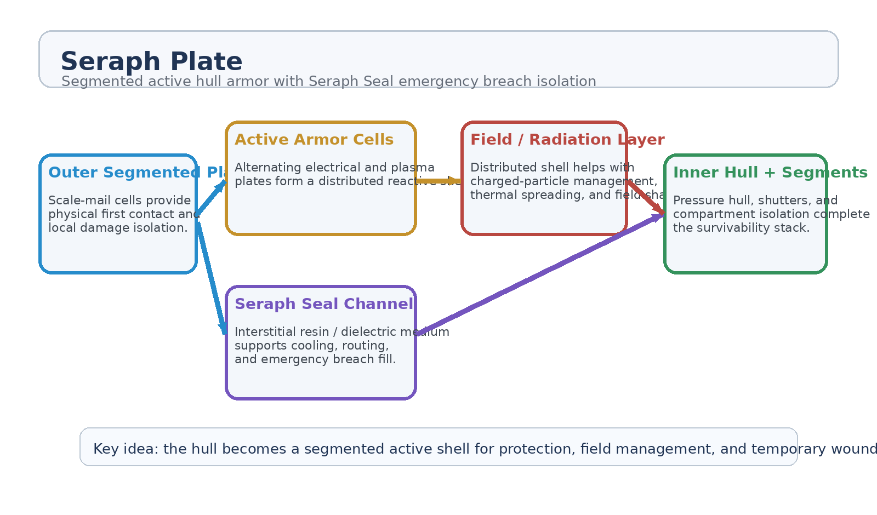
Figure 1. Seraph Plate v2 architecture with Seraph Seal emergency breach-isolation layer.
1. Concept Thesis
The core idea behind Seraph Plate is that a vessel hull should not be a passive wall alone. It can become a segmented active shell, with each armor cell contributing to impact tolerance, localized routing, and damage isolation. The update introduced here is that the same interstitial channel supporting electrical, plasma, dielectric, or thermal behavior can also serve as a survivability bloodstream in an emergency.
This creates a layered philosophy: the outer cells absorb and react, the active channels route and shape, the resin layer closes wounds, and the inner hull preserves long-term pressure integrity.
2. Layered Architecture
Layer | Subsystem | Primary Function | Outcome
L1 | Outer Segmented Plates | Provide scale-mail-like physical first contact and damage isolation across many small cells. | Local survivability
L2 | Active Electrical / Plasma Cells | Alternate armor cells with electrical and plasma-capable functions for distributed shell behavior. | Reactive protective shell
L3 | Interstitial Resin Channel | Carry dielectric resin, cooling medium, or response material between hull layers. | Routing + survivability medium
L4 | Seraph Seal Mode | Inject or shift resin into damaged segments to slow decompression and isolate rupture zones. | Temporary wound closure
L5 | Inner Hull and Shutters | Maintain pressure integrity and compartment control once the initial breach response has occurred. | Long-term recovery

2.1 Why Segmentation Matters
Segmentation is the strongest structural feature in the concept. Instead of one large conductive or reactive wall, the hull is divided into many controlled cells. That means damage can remain local, routing can be compartmentalized, and failure in one region is less likely to cascade through the entire shell.
• Localized fault isolation instead of one continuous catastrophic bus.
• Better repairability through modular plate replacement.
• Independent shutoff or gating of compromised armor cells.
• Regional tuning for different threat or heat-load profiles.
2.2 Active Shell Behavior
Alternating electrical and plasma-capable plates allow the hull to behave like a distributed tertiary shell rather than simple cladding. At a high level, this supports charge distribution, field shaping, thermal spreading, and partial charged-particle or radiation-management roles. The shell should be framed as a support layer for field and survivability management, not as an invincible force field.
3. Seraph Seal: Emergency Breach Response
The major update in this version is Seraph Seal, the emergency role of the interstitial resin channel. When a breach, crack, puncture, or seam failure is detected, the resin medium can be redirected, expanded, hardened, foamed, gelled, or otherwise concentrated into the affected segment to create a temporary barrier between the vessel interior and vacuum.
This does not replace shutters, bulkheads, or repair systems. It serves as the first emergency plug, buying time for the deeper containment layers to take over.
• Local seal formation at the damaged segment.
• Temporary pressure-loss reduction during decompression events.
• Thermal and particulate buffering at the wound site.
• Segment-level isolation rather than shipwide flooding or collapse.
• Recovery time for shutters, drones, or crewed repair to complete long-term containment.
3.1 What Seraph Seal Does Not Do
Seraph Seal should not be described as magic immortal armor. It is strongest against small punctures, crack propagation, seam failures, and localized plate damage. It is weaker against catastrophic structural loss, large open fragmentation, or sustained burn-through across many segments at once. Its role is time-buying and damage localization, not miracle invulnerability.
4. Radiation and Environmental Role
As a hull concept, Seraph Plate can also contribute to environmental protection, especially by supporting charged-particle management, heat spreading, and some field-shaping behavior. The safest high-level statement is that the shell may support partial radiation mitigation and environmental hardening as part of a broader layered shielding architecture. It should not be framed as a complete answer to every radiation class by itself.
5. Proof-of-Concept Build Path
Phase | Goal | Bench Activity | Success Signal
P1 | Segmented plate demo | Build a small segmented plate array with isolated cells and separate interstitial channel paths. | No uncontrolled cross-cell failure.
P2 | Active routing demo | Show controlled electrical/plasma-like or surrogate routing behavior across alternating plates. | Repeatable localized shell response.
P3 | Resin channel demo | Run dielectric/resin medium through separated inner and outer channels without fouling or blockage. | Stable channel integrity.
P4 | Breach-seal test | Introduce controlled puncture or seam fault into a test panel and trigger Seraph Seal response. | Temporary leak reduction and segment isolation.
P5 | Recovery stack demo | Pair resin seal with shutters or secondary membrane to show handoff from first emergency plug to longer-term containment. | Coherent layered survivability workflow.

6. Measurements
• Leak-rate reduction after Seraph Seal activation.
• Time between breach detection and temporary seal formation.
• Cross-contamination or clogging rate in interstitial channels.
• Thermal spreading performance across segmented active armor cells.
• Fault propagation behavior across adjacent cells after local damage.
• Recovery time from first emergency seal to full compartment isolation.
7. Safety and Maintenance Boundaries
The biggest technical risks in this concept are exactly the ones segmentation is meant to manage: fouling, shorting, thermal runaway, clogging, and shared-channel failure. The architecture therefore has to remain compartmentalized and maintainable.
• Keep inner and outer housings separated so resin and active routing do not foul each other.
• Design independent cell isolation so one fault does not poison the whole shell.
• Preserve manual or automated maintenance access to channels and plate modules.
• Treat Seraph Seal as a temporary barrier layer, not a substitute for bulkheads and long-term repair.
• Prevent any single continuous failure path through shared routing channels.
8. Integration Opportunities
• Use Seraph Plate as the outer survivability shell for high-value vessels or exposed compartments.
• Pair Seraph Seal with autonomous repair drones and pressure-hull shutters.
• Use the segmented shell as a field-aware layer beneath higher passive armor or deeper radiation shielding.
• Integrate with thermal architecture so the hull helps spread heat instead of merely suffering it.
9. Conclusion
Seraph Plate becomes much stronger once the resin layer is treated as more than a buffer. In this updated framing, the hull is not only segmented active armor; it is also a wound-closing, time-buying survivability system. The outer plates localize impact, the active shell helps manage field and thermal behavior, and Seraph Seal temporarily closes the ship against true space until deeper containment takes over.
That makes the concept read less like armor cosplay and more like a real layered ship-survivability architecture.
Working one-line doctrine: Seraph Plate protects the ship as armor; Seraph Seal keeps the wound closed long enough for the ship to survive it.

